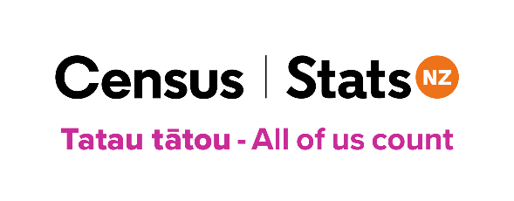
29 May 2024
2023 Census media advisory/release
Note to media: This media advisory provides regionalised information from the census data published today. For the national media release see: First results from 2023 Census - older, more diverse population and an extra 300,000 people between censuses

2023 Census data highlights: NORTHLAND REGION
Stats NZ released the first data from the 2023 Census today – census usually resident population, Māori descent, age, ethnicity, and dwelling counts at a national level, regional council level, and territorial authority (cities and districts), and Auckland local board level.
Top line statistics* for the Northland region include:
- The census usually resident population totalled 194,007 in 2023 (up 8.3 percent since the 2018 Census).
- 77,475 people of Māori descent were counted in the 2023 Census, accounting for 39.9 percent of the regional population. The Māori descent population increased 11.9 percent between the 2018 and 2023 Censuses.
- For proportions of people by ethnic group in Northland in 2023:
- 73.0 percent were European
- 37.4 percent were Māori
- 4.9 percent were Pacific peoples
- 4.8 percent were Asian
- 0.7 percent were Middle Eastern/Latin American/African (MELAA)
- 1.1 percent were Other ethnicity.
Note: Ethnic group is a self-determined affiliation, with people identifying as belonging to one or more ethnicities. Māori counts are measured in two ways in the census. Māori descent is based on whakapapa, while ethnicity is a self-determined cultural affiliation.
- The median age of people living in Northland in 2023 was 43.2 years, compared with 42.6 years in 2018.
- 88,092 dwellings were counted in 2023 (an increase of 8.8 percent since 2018).

* Note to media: Attached to this email is an infographic with key statistics. We have also enclosed the same graphic but for the whole of New Zealand as a point of comparison. Please feel to use these in print, and on your digital platforms.
[ends]

Media enquiries:
Tracy Dillimore
census.communications@stats.govt.nz
027 208 7771

